Cross-cultural discovery at the Louvre

*L'objectif de cette visite est de vous permettre de découvrir le plus grand musée du monde à travers des ouvres liées à la thématique du séminaire. Certains de ces chef-d'œuvres représentent des scènes liées aux "trois cultures" .. A vous de les trouver et de répondre aux questions suivantes!
*The aim of this visit is to allow you to discover the World's biggest museum through a series of works related to the issue raised by the seminar. Some of these masterpieces perform different acts and topics relevant to the "three cultures"… It's up to you now to find them out and to answer to the following questions!

Photo | Lieu  Location | Question?  Question? | Réponse  Answer
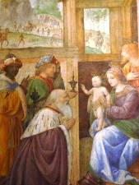 |  | 1. Quel est le rôle prévu pour les trois personnages principaux ? A quelle religion se rapportent-ils ?  1.What is the role of the three main characters? To which religion do they refer to?
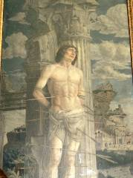 |  | 2. Qu’est ce qu’un martyre ? quel est le nom de celui-ci ? Connaissez-vous d’autres ? A quelles religions se rapportent-ils ?  2. What is a martyr? What is the name of the one on this painting? To which religion does he refer to?
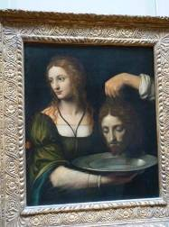 |  | 3. Connaissez-vous l’histoire qui a inspiré ce tableau ? Raconter ?  Où est enterré le corps ?  3. Do you know the story behind this painting? Can you tell it? Do you know where the corpse is buried?
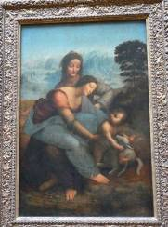 |  | 4. Quelle est la caractéristique de ce tableau ?  4. What is particular about this painting?
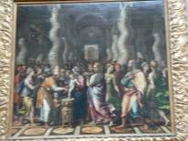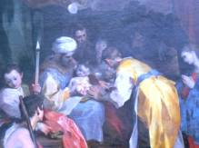 |  | 5. Quelle cérémonie est illustrée dans ces deux tableaux ? Quelles sont les religions concernées ?  5. Which ceremony is celebrated according to the paintings? What are the religions concerned?

Photo | Lieu  Location | Question?  Question? | Réponse  Answer
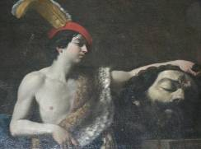 |  | 6. Quelle est l’histoire racontée par ce tableau ? Quel en est le symbole ?  6. Which story is told through this painting?  What is its main symbol?
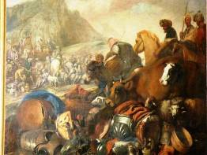 |  | 7. Quel personnage important dans les trois religions est représenté dans ce tableau ?  7. Who is the character, capital to the three religions, represented here
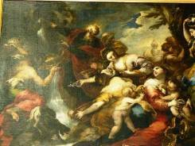 |  | 8. Quel personnage fait jaillir de l’eau de la montagne ? Quelle place a-t-il dans chacune des trois religions ?  8. Who spurts water out of the rocks? How is he regarded in each of the three religions?
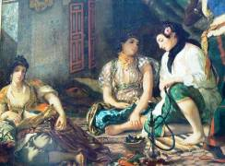 |  | 9. Dans quel pays la scène se déroule-t-elle ? Qu’est ce que ce tableau a de particulier ?  9. Where do you think the scene is taking place? What is particular about this painting?
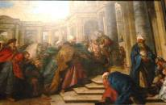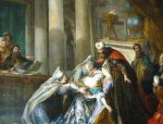 |  | 10. Ces deux tableaux représentent un épisode très important pour une religion, laquelle ? De quoi s’agit-il ?  10. The two paintings draw a very famous episode in one of the three religion. What is it about?

Photo | Lieu  Location | Question?  Question? | Réponse  Answer
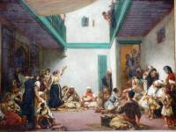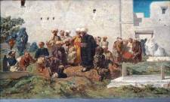 |  | 11. Ces deux tableaux représentent des événements de la vie quotidienne. De quoi s’agit-il ?  11. The two paintings offer views of the everyday life. Do you recognize them?
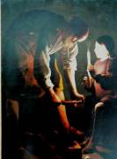 |  | 12. Qui est le personnage principal dans le tableau ? Quelle est sa place dans le Religion ?  12. Who is the main character here?  Which place does he hold in Religion?
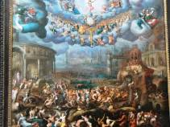 |  | 13. Ce tableau illustre un événement qui se retrouve dans plusieurs religions. Lequel ?  13. Here is a very important event for different religions? What is it exactly?
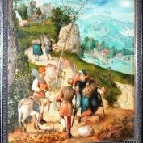 |  | 14. Existe-t-il un lien entre le sujet de ce tableau et des fêtes religieuses ? Lequel ?  14. Is there any link between the painting and some religious feasts? Which one?
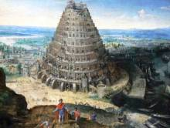 |  | 15. Quel est le symbole derrière ce tableau ?  15. What is the main symbol out of this painting?

Photo | Lieu  Location | Question?  Question? | Réponse  Answer
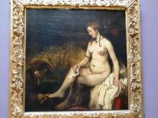 |  | 16. Observez ce tableau ! Pensez-vous que la religion et l’amour font bon ménage ?  16. Look very carefully at the painting! Do you think love and religion go hand in hand?
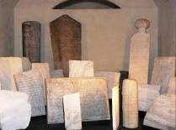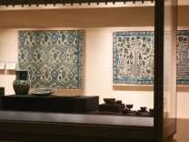 |  | 17. Vous finissez le parcours avec le département consacré aux arts de l’islam. Quelle en est la spécificité ?  17. You are reaching the last step of this journey with the Islamic art department. What is its main specificity?

Recommandations!

Travailler en équipes!
- Le questionnaire est individuel mais certaine questions peuvent recevoir une réponse collective
- Suivez le parcours indiqué
- N'hésitez pas à regardez, observer, appréciez, mais surtout ne touchez pas les oeuvres!
- Consultez les plaques et planches disponibles dans différentes langues
- Retrouvez les autres groupes au point de rencontre à la fin du parcours! Soyez à l'heure pour le debriefing final !

Recommendations

Work in teams
- The questionnaire is individual, but some question may accept a collective answer
- Follow the journey's plan
- Feel free to observe, appreciate but don't touch the works
- Read the boards and plates offered in the rooms available in different languages
- Join the other groups at the meeting point at the end of your journey. Be on time!
Technical information: Cross-cultural Discovery at the Louvre

Title | Monday 29th, 9:30-13:00  Responsible: Bernard, Dalila  Venue: Museum Louvre
Background

Aims | To discover history and values of the three cultures and of the concept of laïcité through the use of visual arts
Objective | - To introduce participants to the theme of the TC  - To develop a creative group-building activity  - To understand the representation of the three cultures and of laïcité in visual arts.  - To discover Le Louvre, the biggest Museum in the world.
Competences | - Individual thinking,  - Group work  - Creativity
Methodology and methods | Individual work, small groups work.  After an explanation about the place itself, the group has been divided in order to do the cross-cultural by group of 5 persons.  Provide to each of the participants a questionnaire; some pictures, the place to find them in the Museum, some questions to answer about it.  Try to have a balance between the 3 cultures through the pictures they have to find.
Implementation | 8:30 Departure by Metro  9:30-11:30 Activity  11:30-12:30 Free visit  12:30-13:00 Debriefing
Tips for the team and participants
Materials needed | Copies of the activity, pens.
Handouts provided | Copies of the activity.
Outcome | Participants got introduced to the
Comments | Adapt the choise of the picture to the target group

